**Artificial intelligence (AI)**

**Links :**

* Main
* Artificial intelligence and solve problems
* Research and optimization
* logic in intelligence research

**screenshots :**

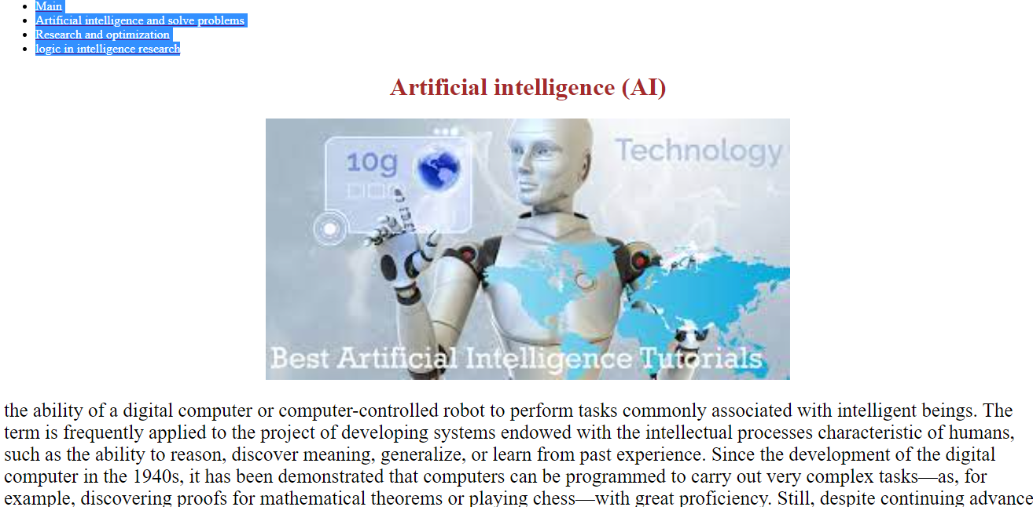

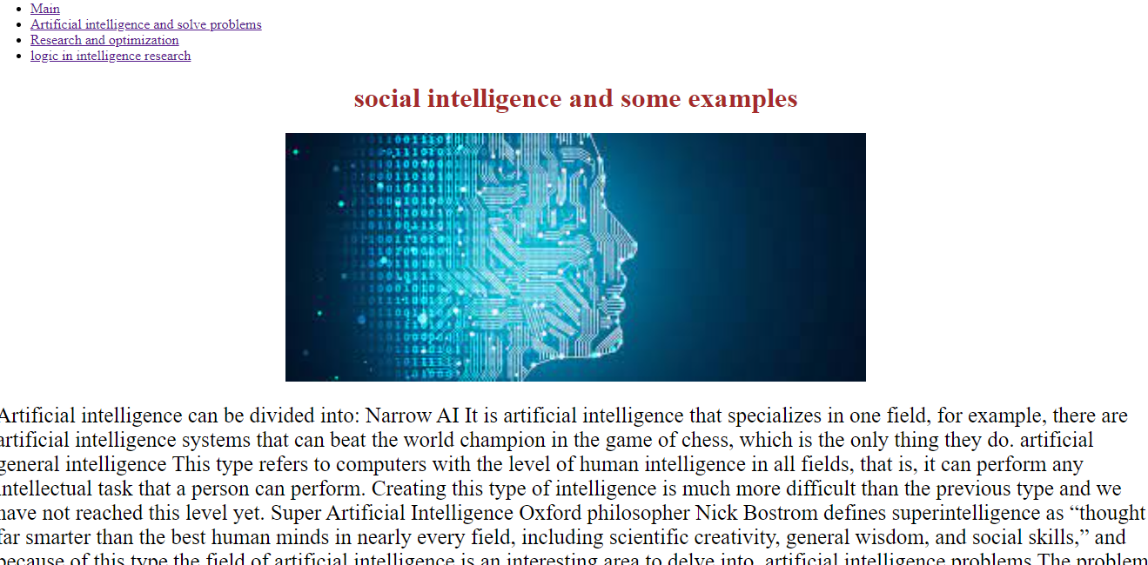

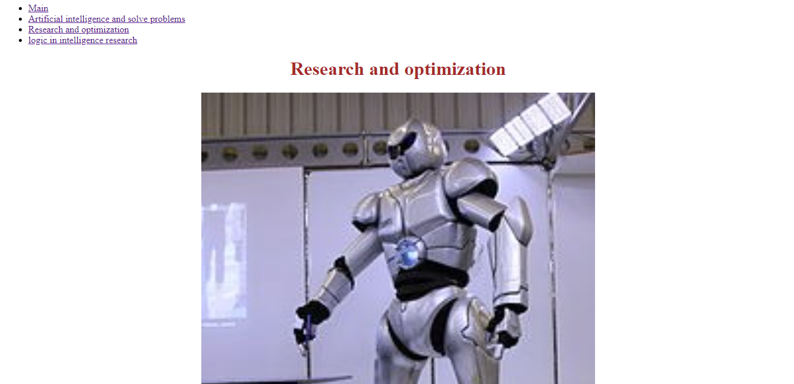

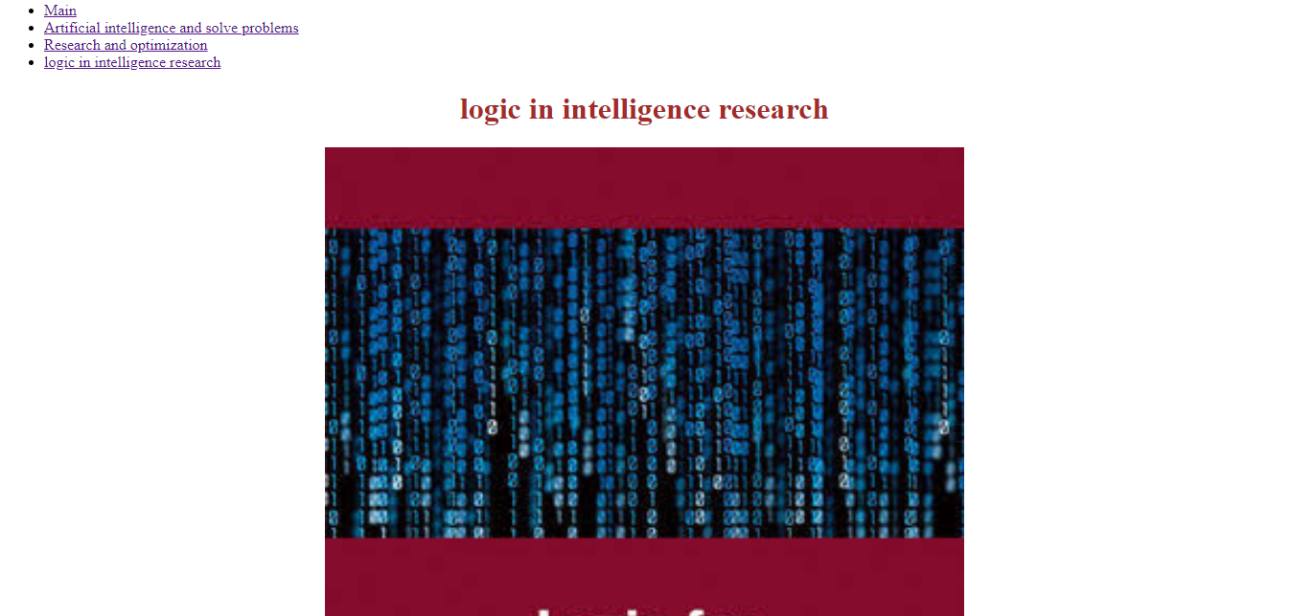

Source code :

